-- 1. Create an appropriate table schema

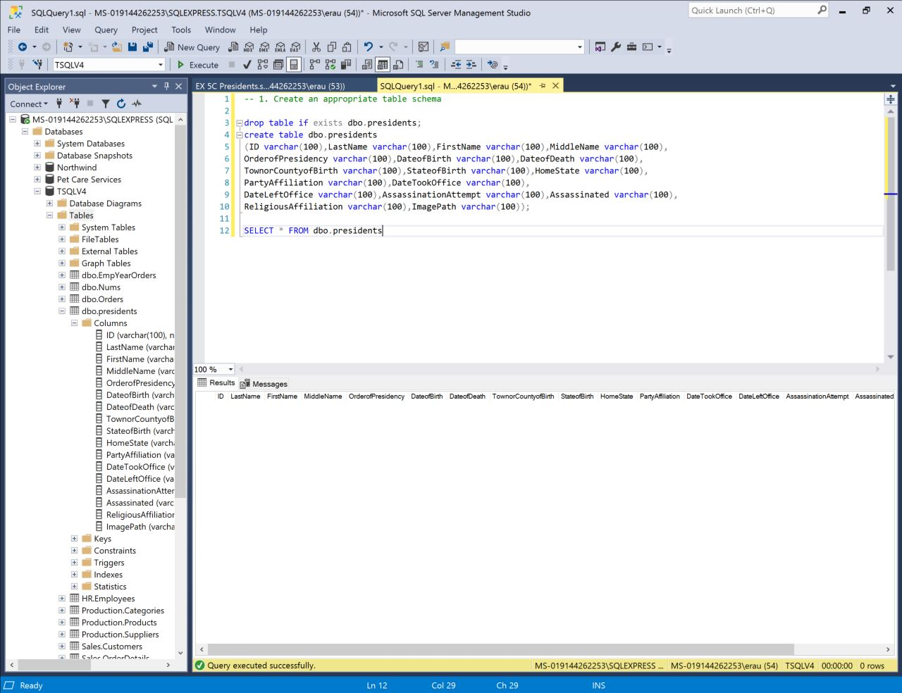

-- 2. Insert the CSV data into the table you just created

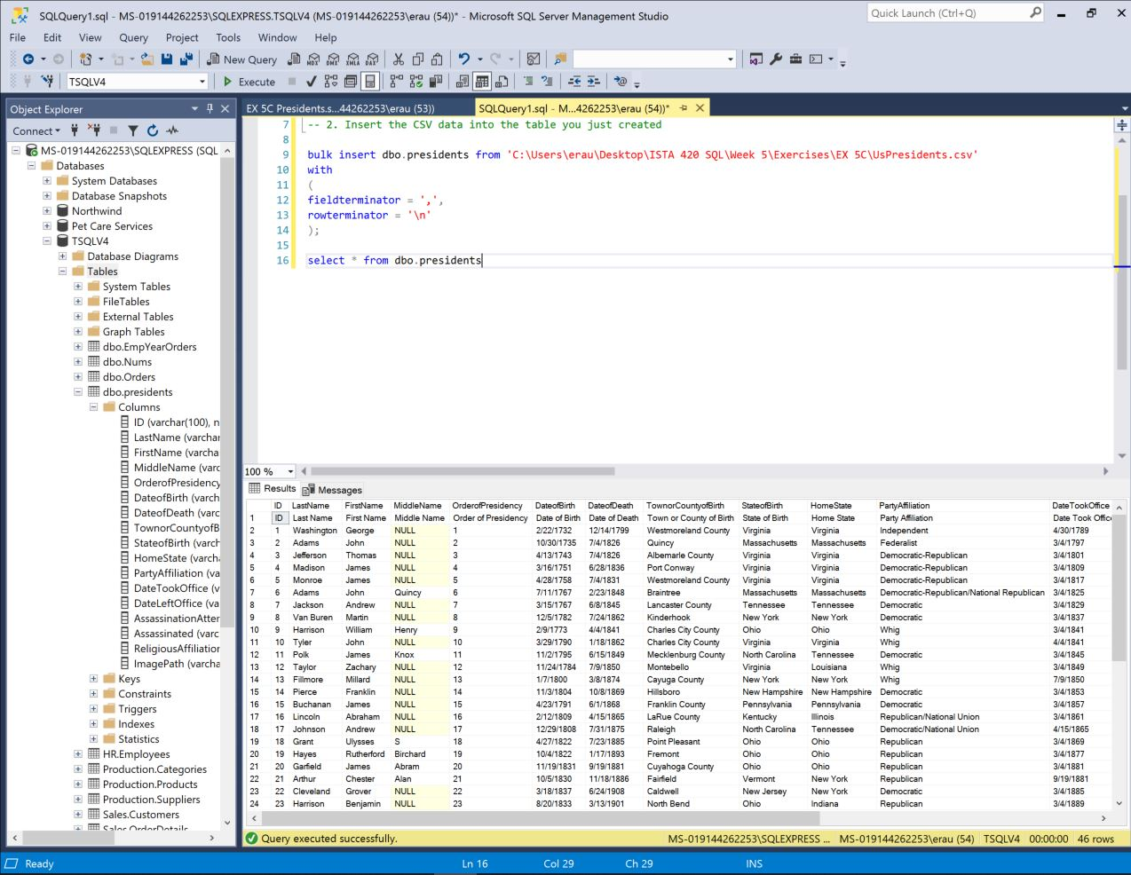

-- 3. Delete the column that contains the path to the images

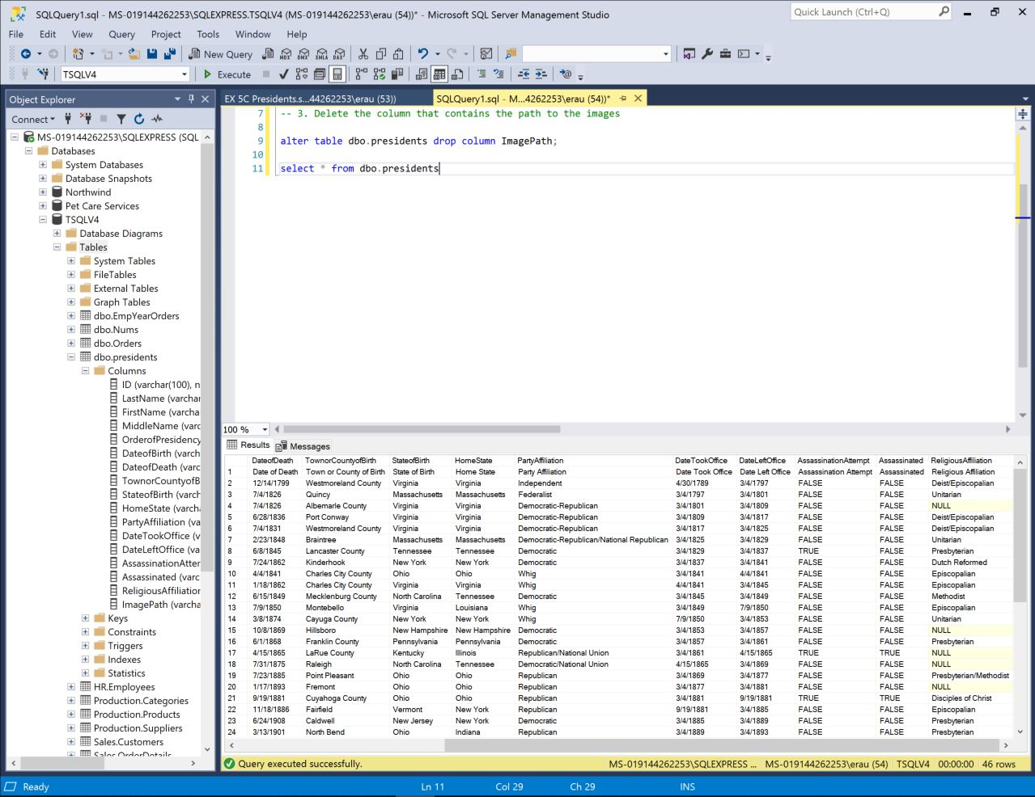

-- 4. Delete first record from table

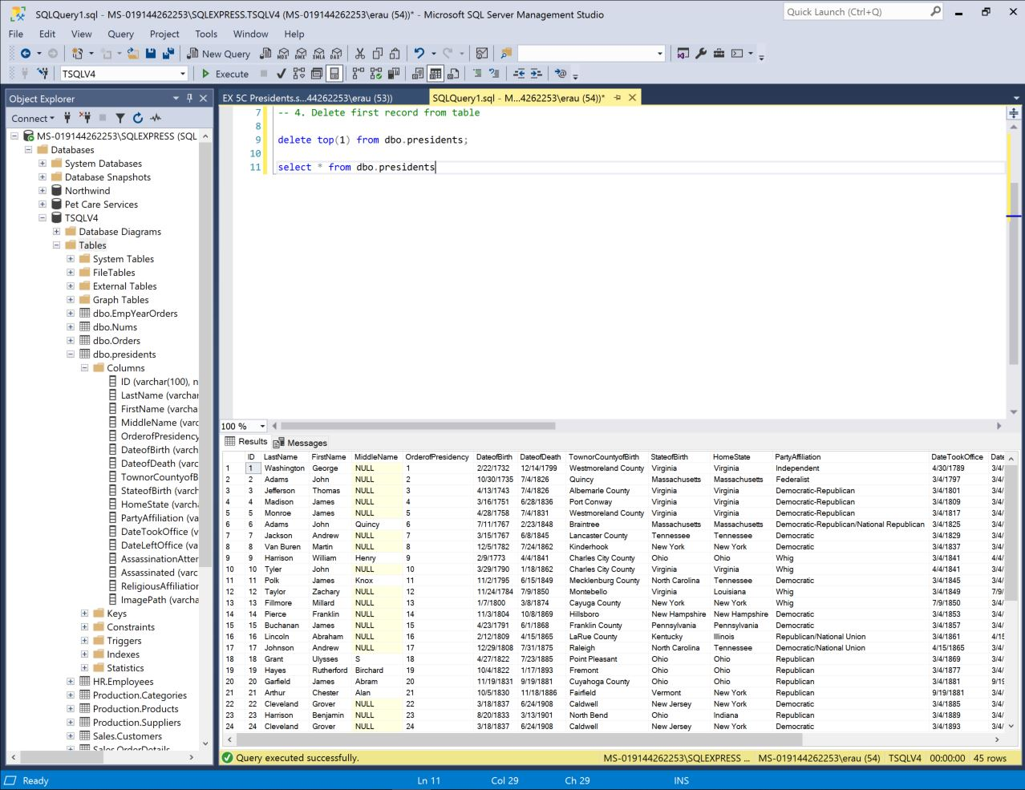

-- 5. Bring data up to date by updating the last row. Use output clause

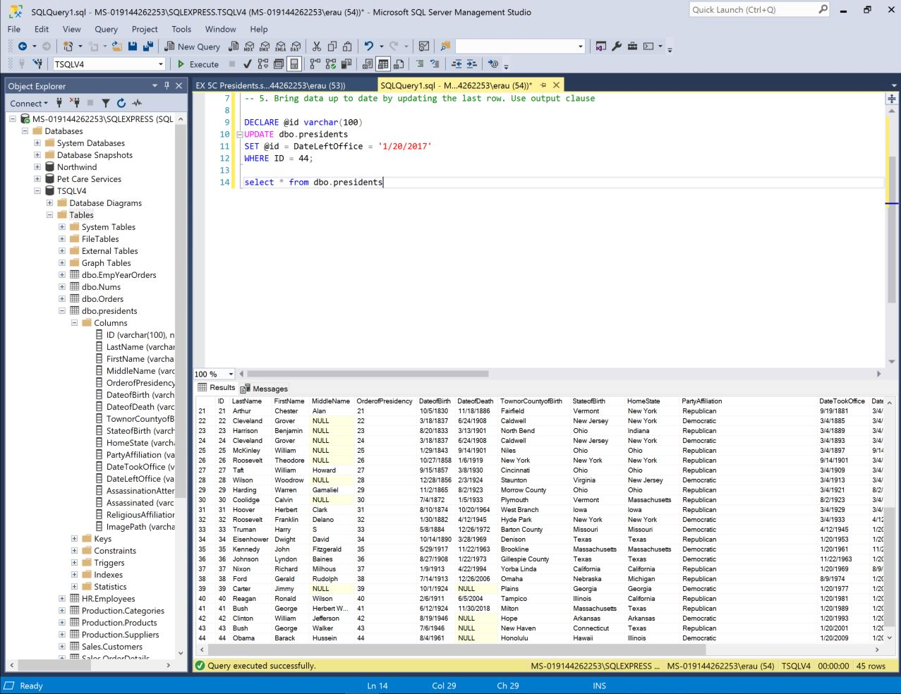

-- 6. Bring data up to date by adding a new row. Use output clause

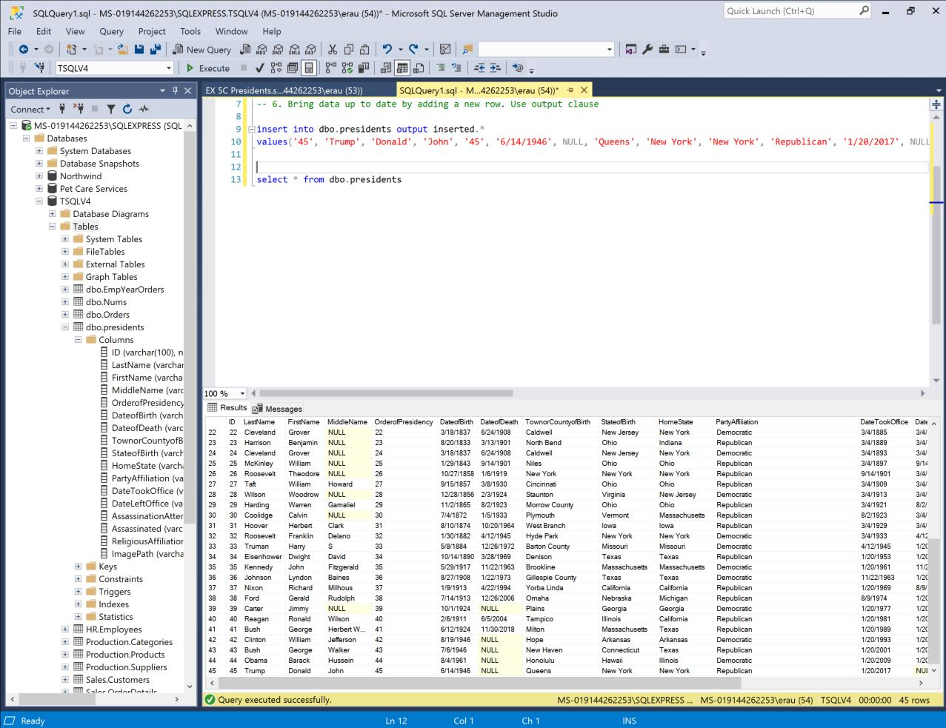

-- 7. How many presidents from each state belonged to each political party? Aggregate by party and state

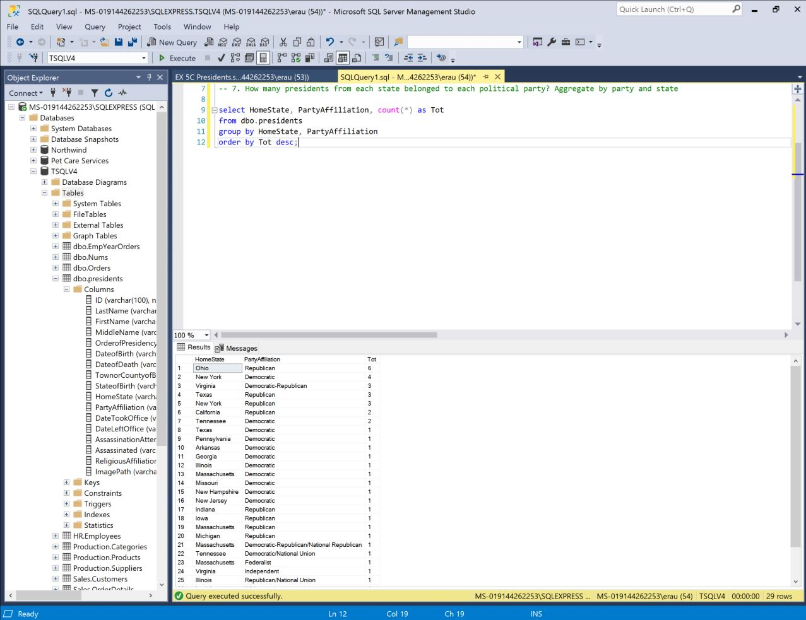

-- 8. Show number of days president was in office

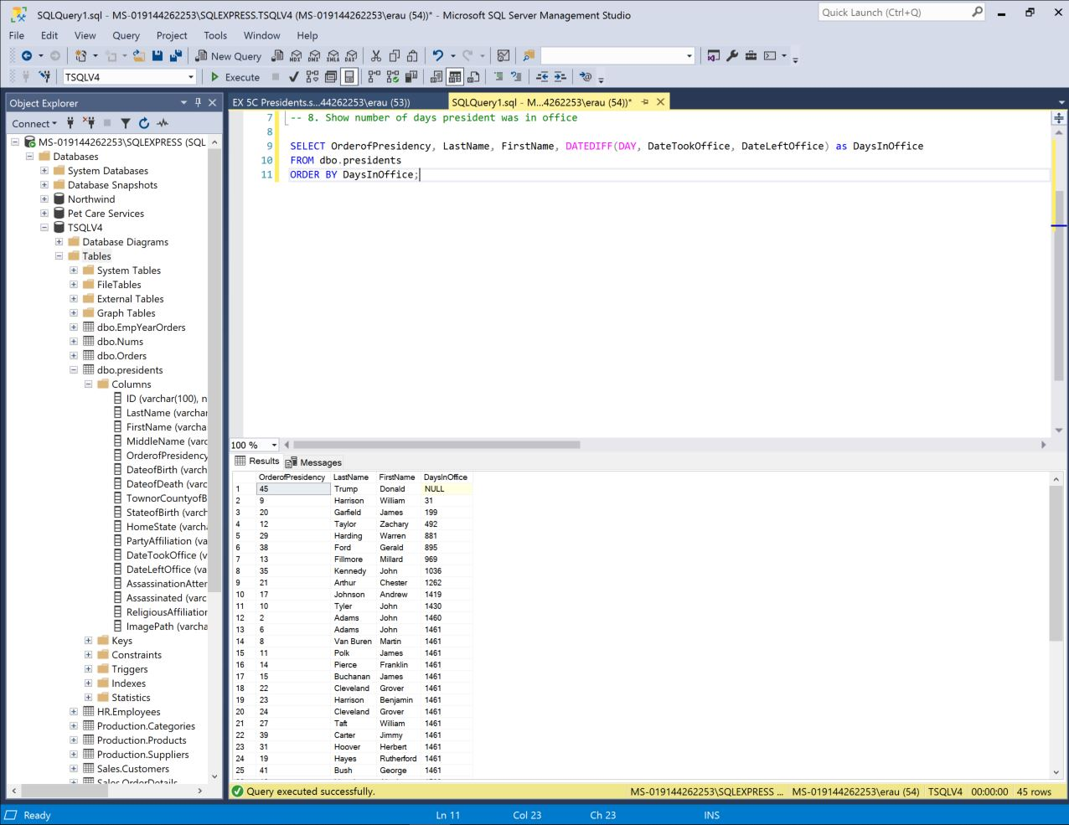

-- 9. Show age of each president when he took office.

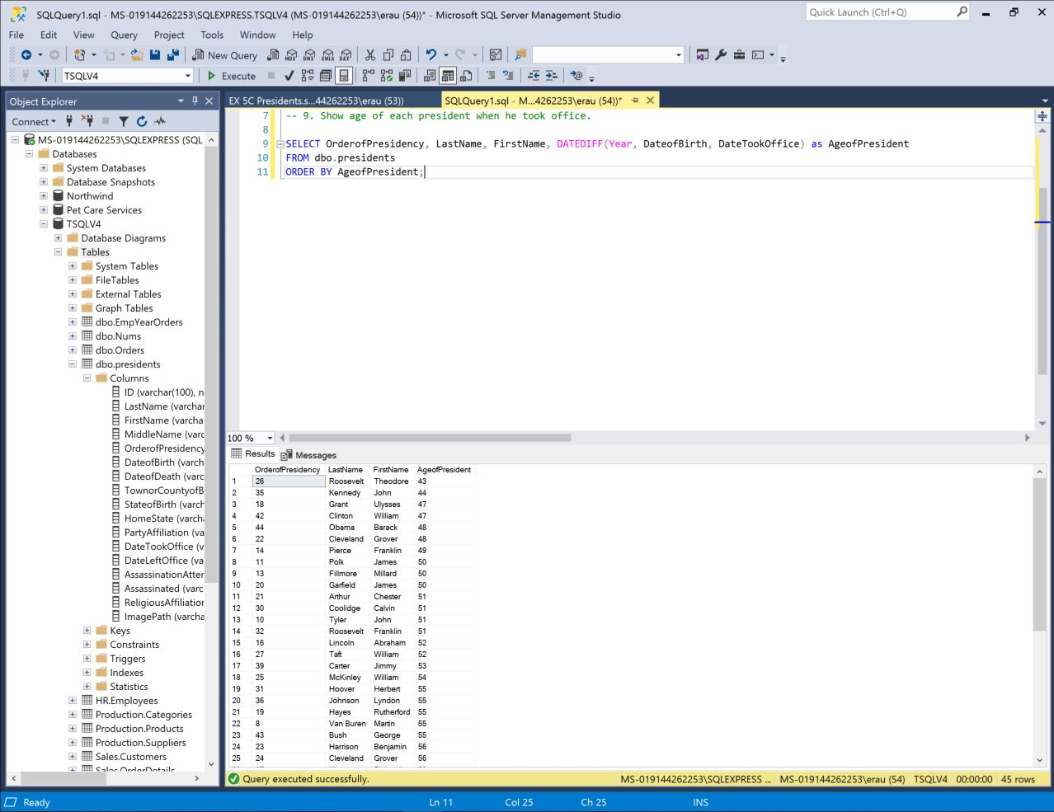

-- 10. See if any correlation between party and religion.

